Hibernate Tutorial Part 1 - Introduction to Hibernate (Concept)

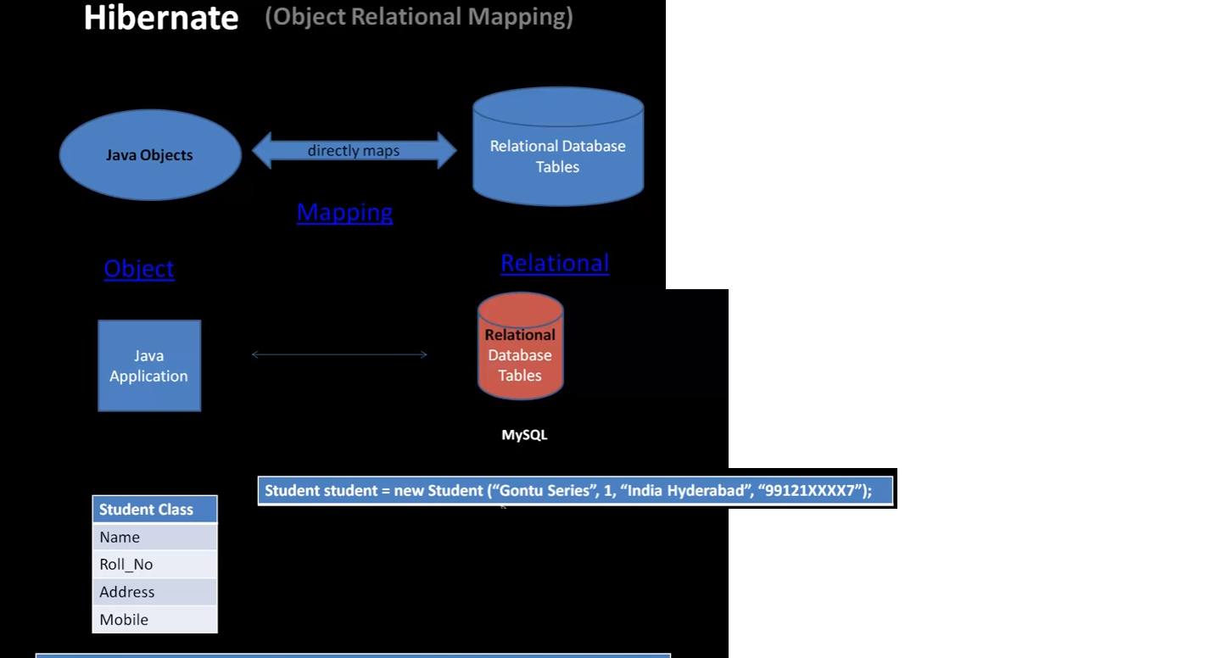

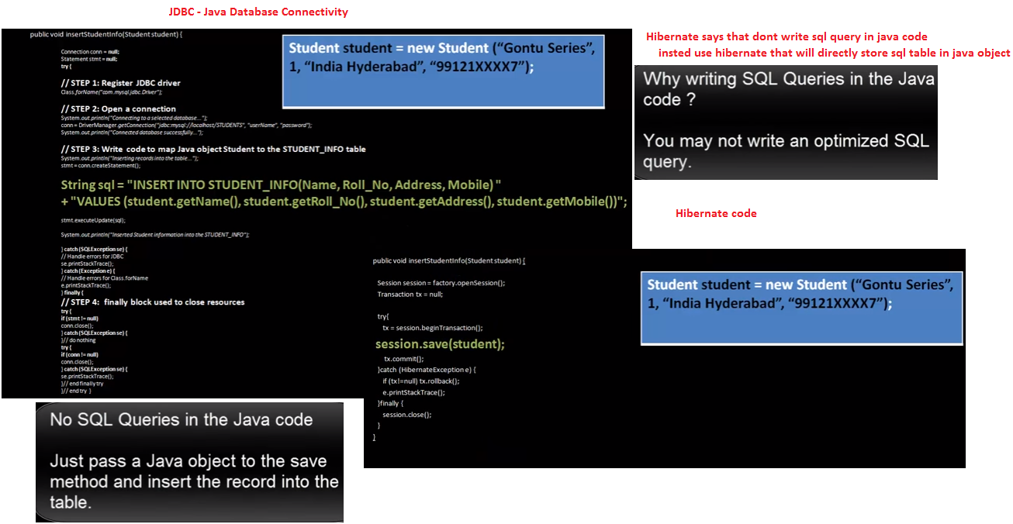

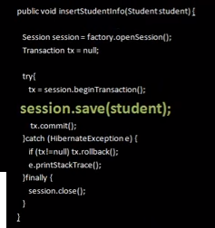

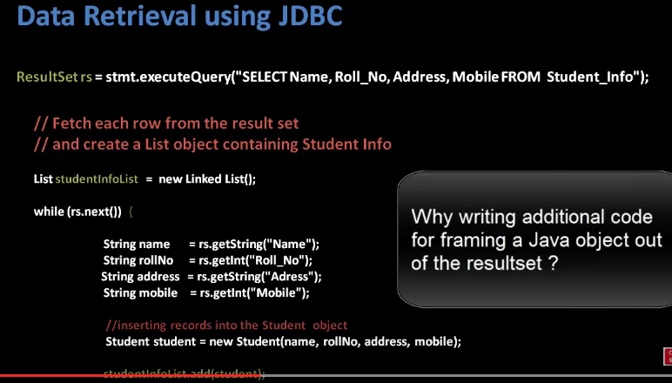

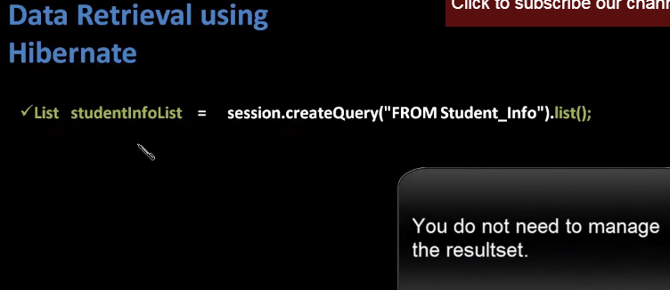

Hibernate Tutorial Part 2 - Hibernate Setup in Eclipse IDE (Hands on)

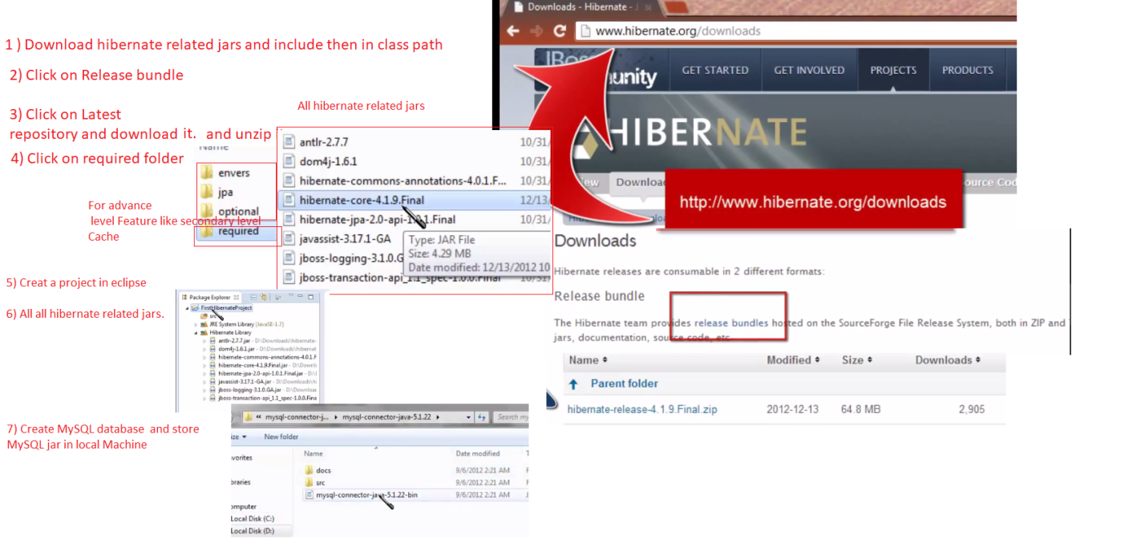

Hibernate Tutorial Part 3 - Installing MYSQL Database (Hands on)

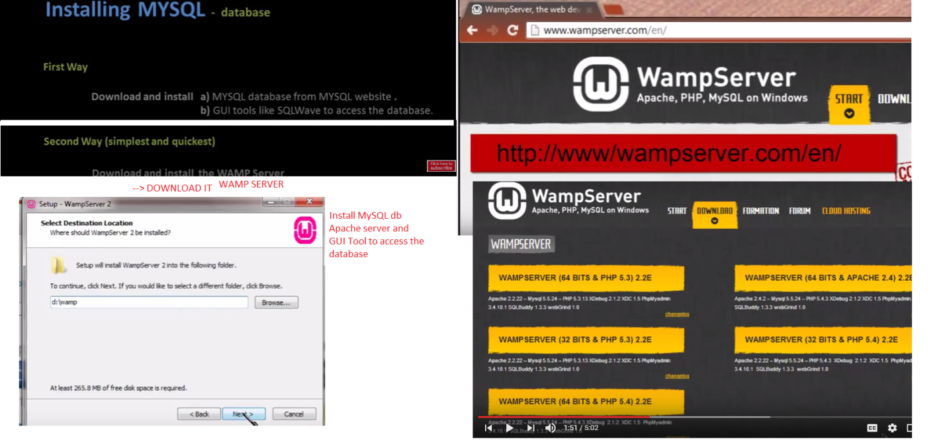

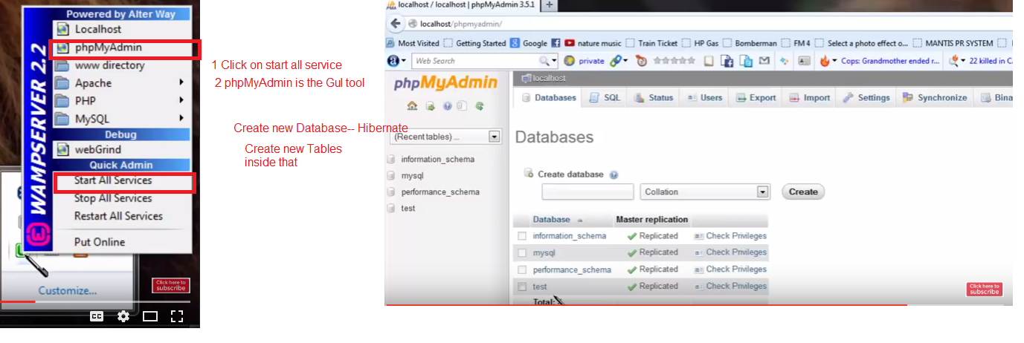

Hibernate Tutorial Part 4 (a) - How to create the first Hibernate Application in Eclipse ( Hands on)

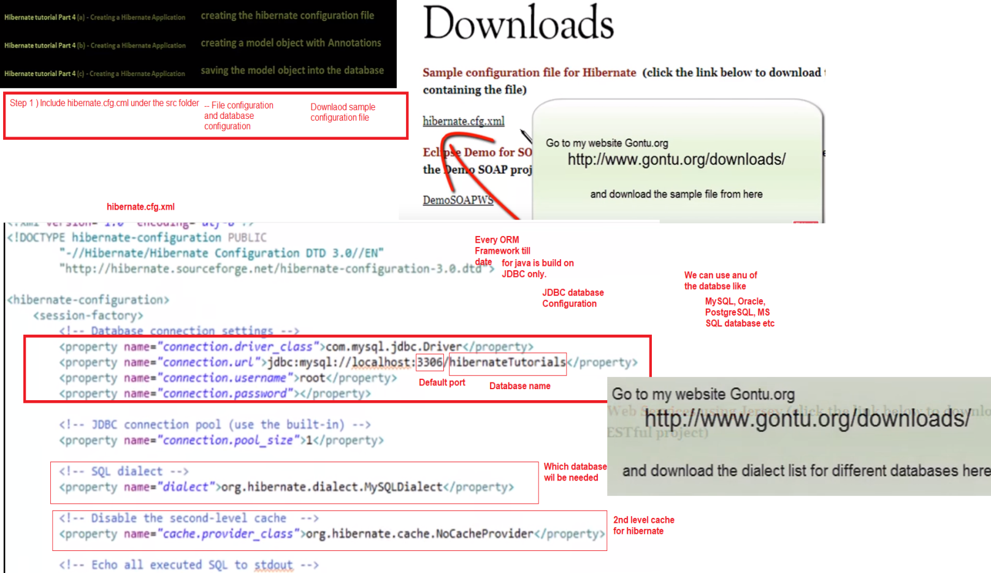

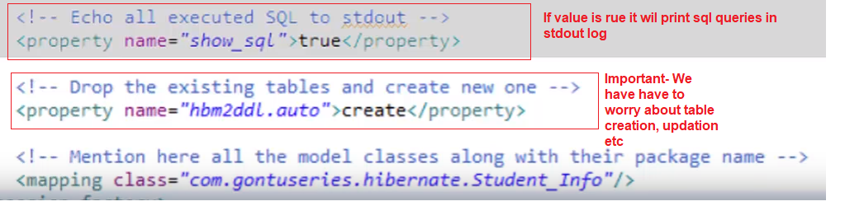

Hibernate Tutorial Part 4 (b) - How to create the first Hibernate Application in Eclipse ( Hands on)

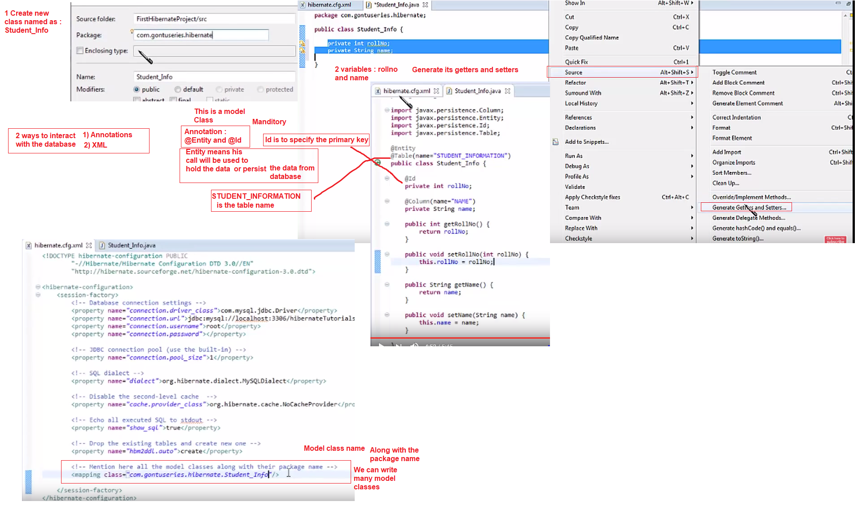

Hibernate Tutorial Part 4 (c) - How to create the first Hibernate Application in Eclipse (Hands on)

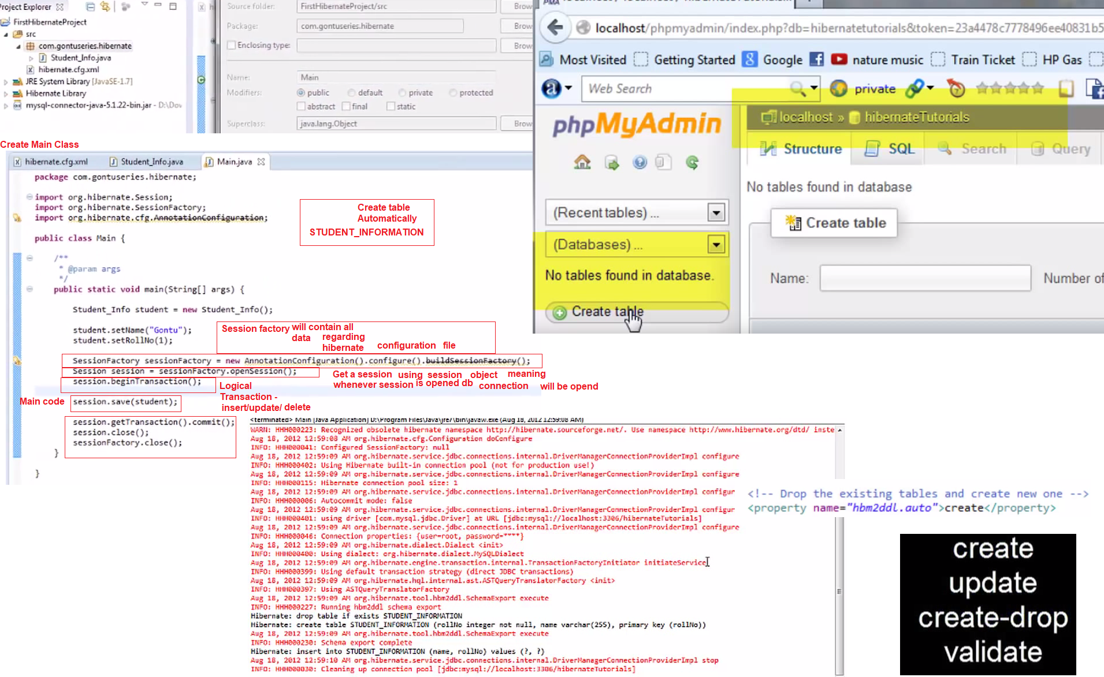

Hibernate Tutorial Part 5 - hbm2ddl.auto property in detail ( Hands on)

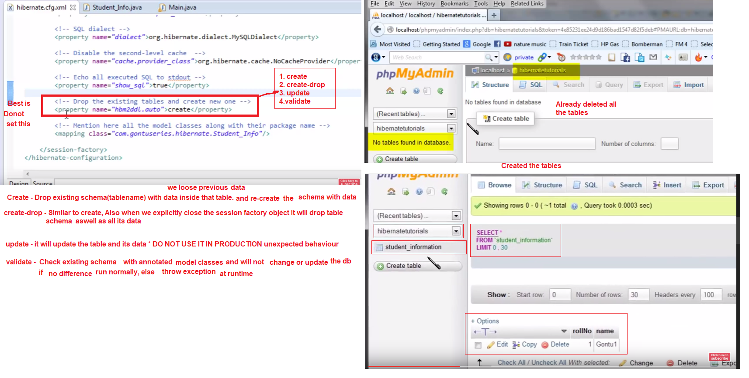

Hibernate Tutorial Part 6 - Most common Annotations in Hibernate (Hands on)

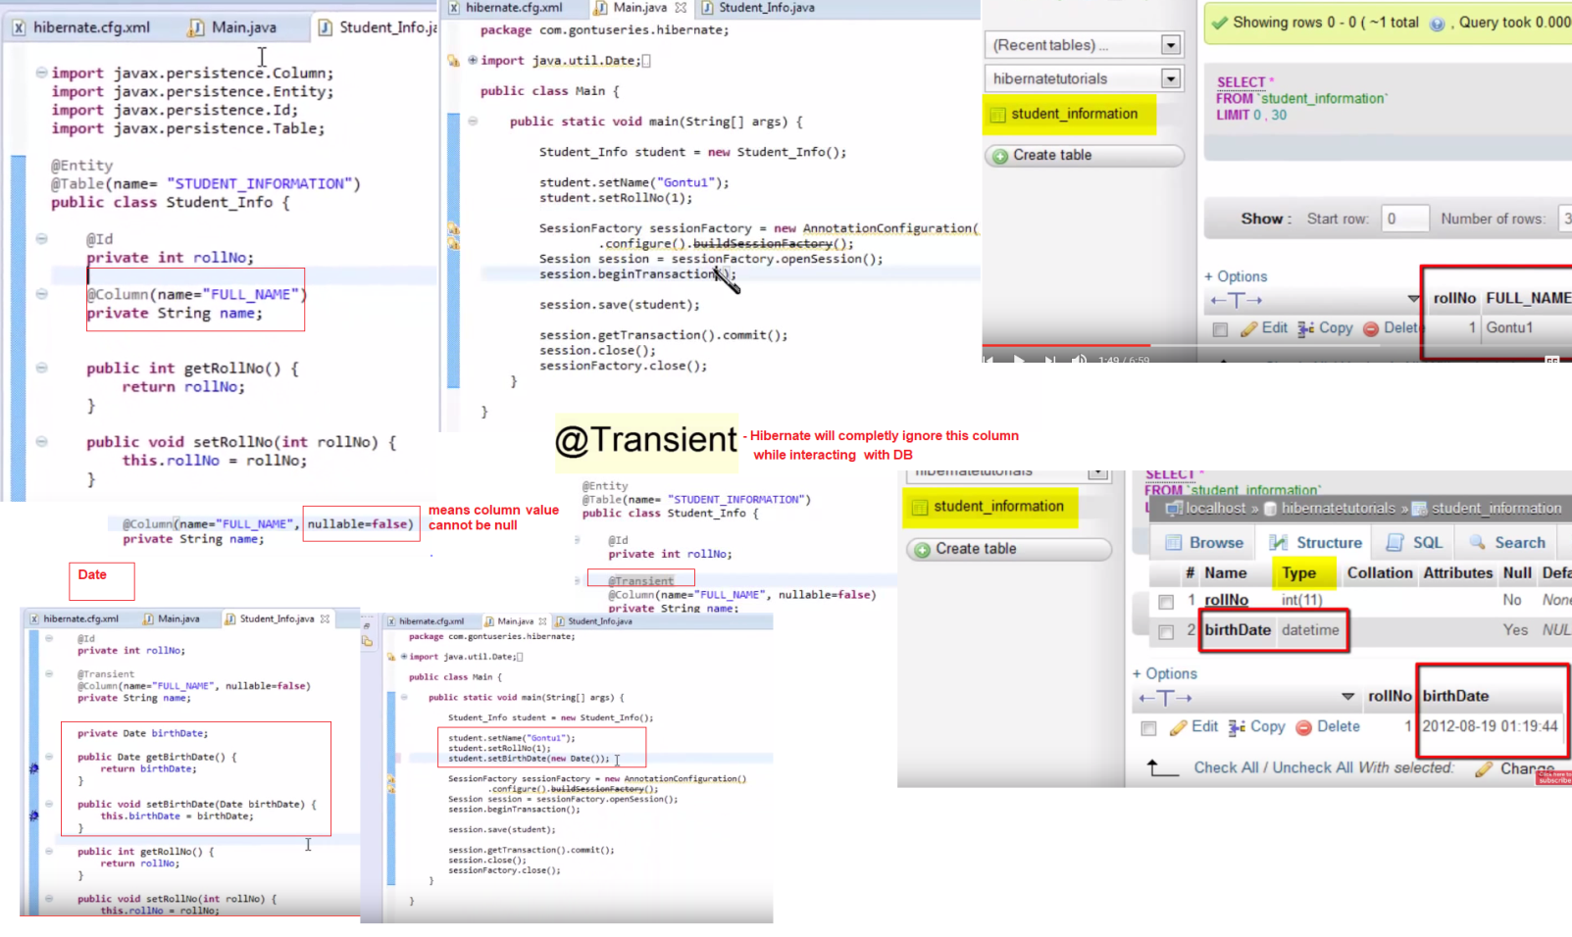

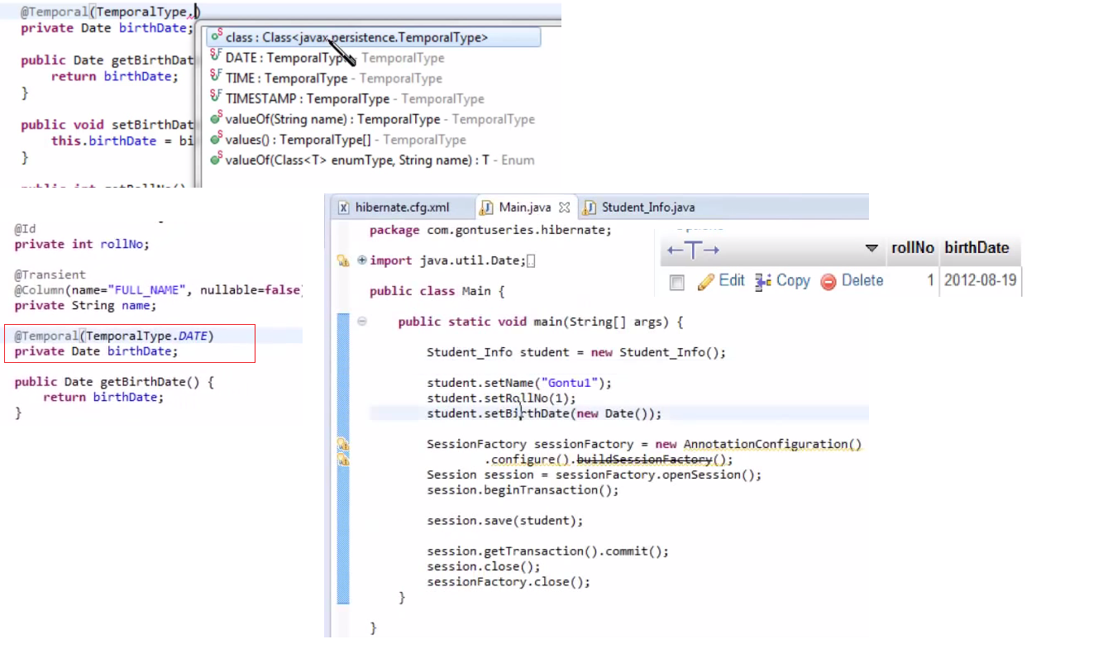

Hibernate Tutorial Part 7 - Primary key Auto - Generation in Hibernate (Hands on)

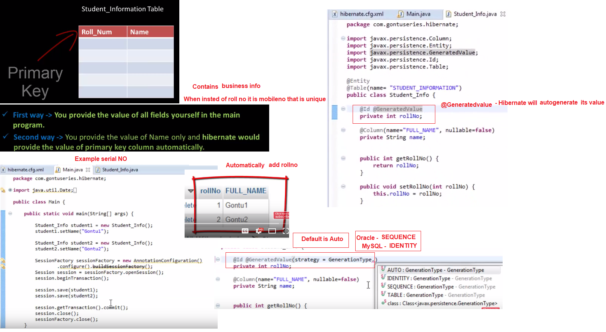

Hibernate Tutorial part 8 - One to One mapping using Annotations

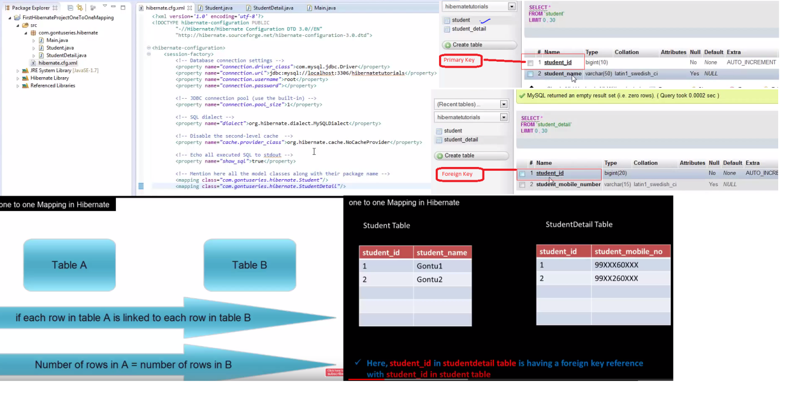

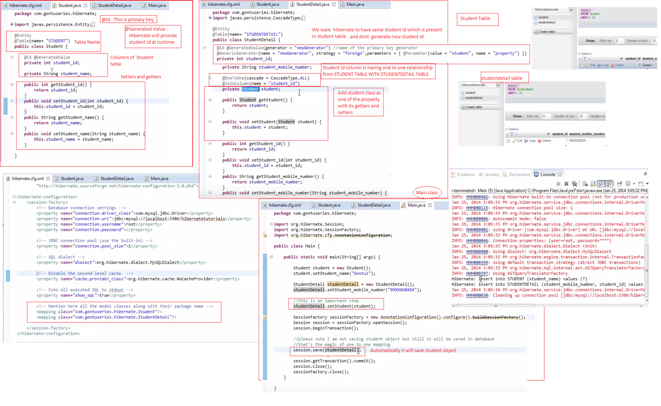

Hibernate Tutorial part 9 - Unidirectional VS Bidirectional One to One Mapping, Cascade Type

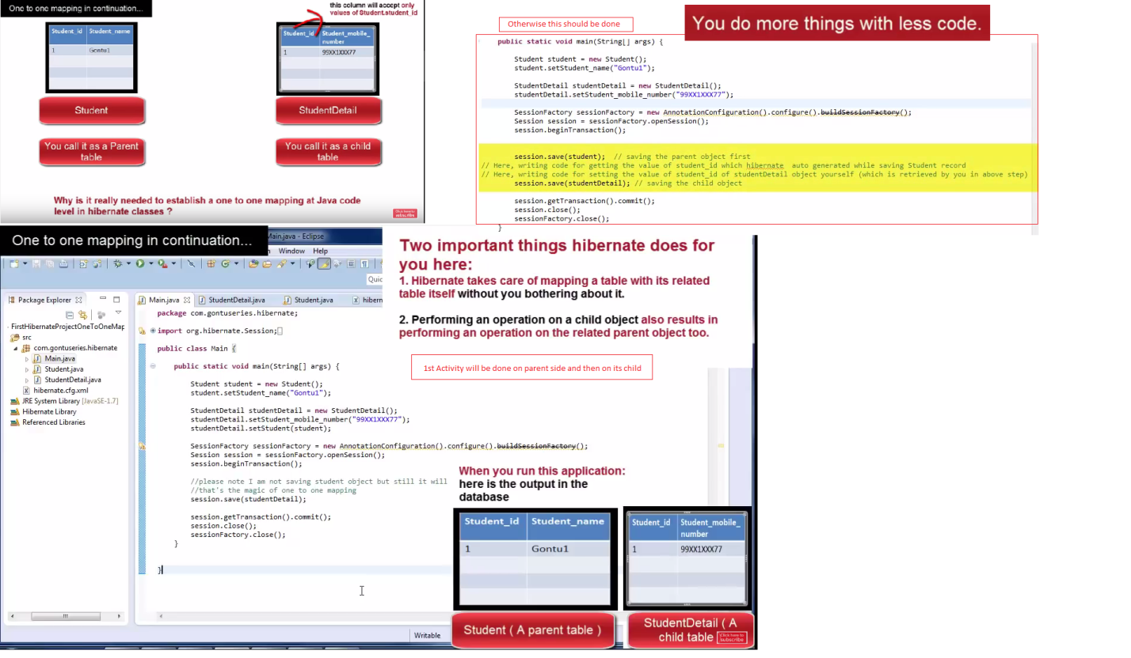

Unidirectional One to One Mapping, Cascade Type

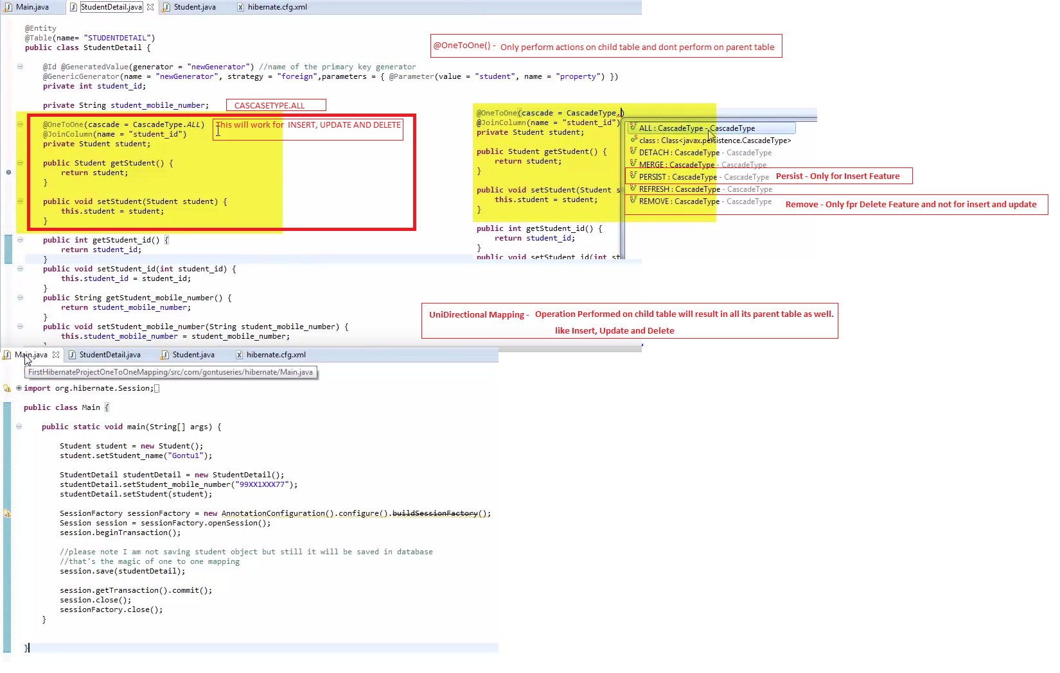

Bidirectional One to One Mapping

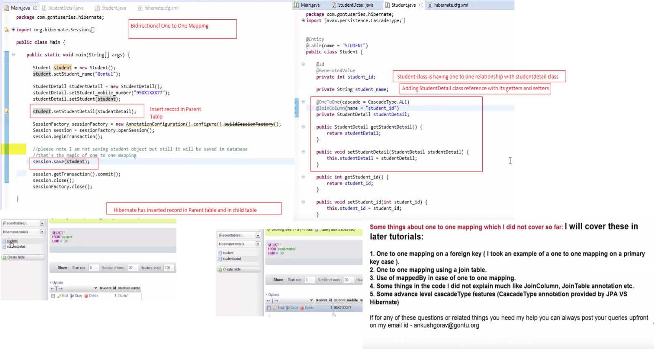

Hibernate Tutorial part 10 - Many to One Mapping in a Hibernate Application in detail

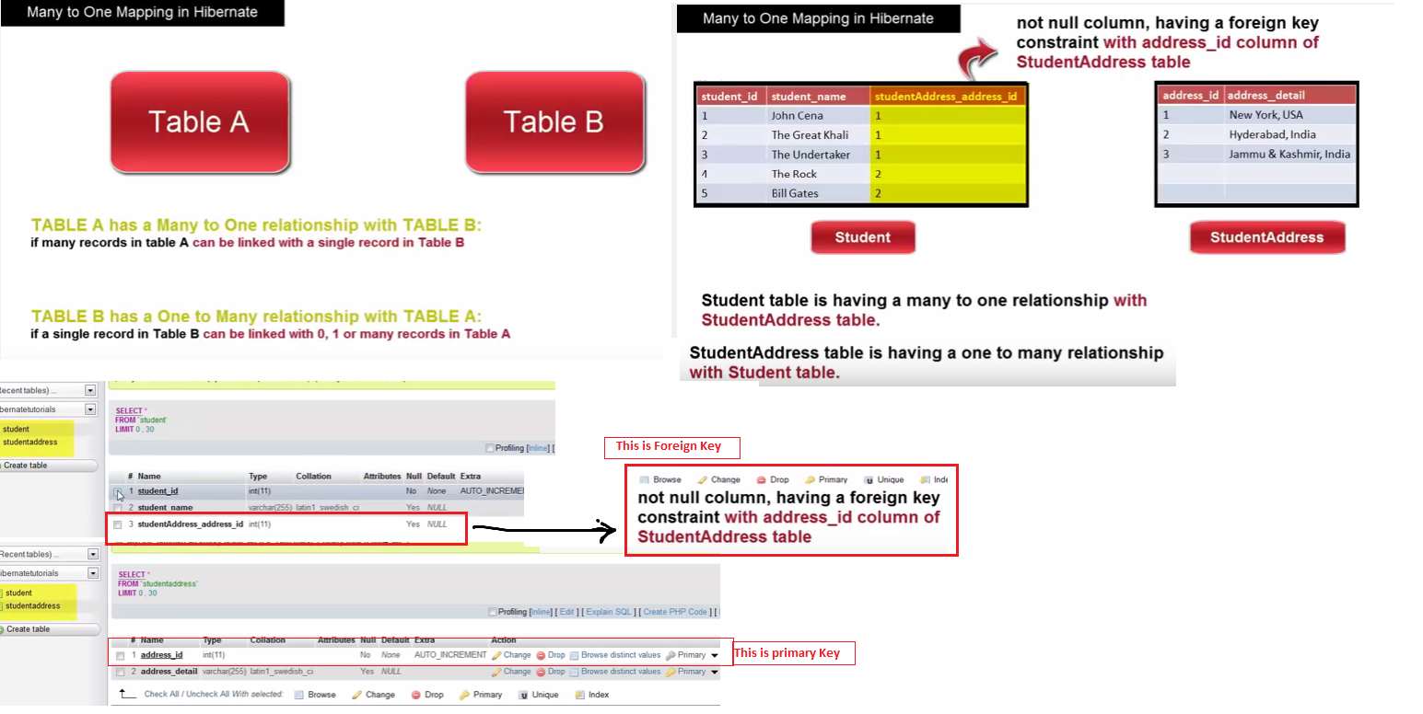

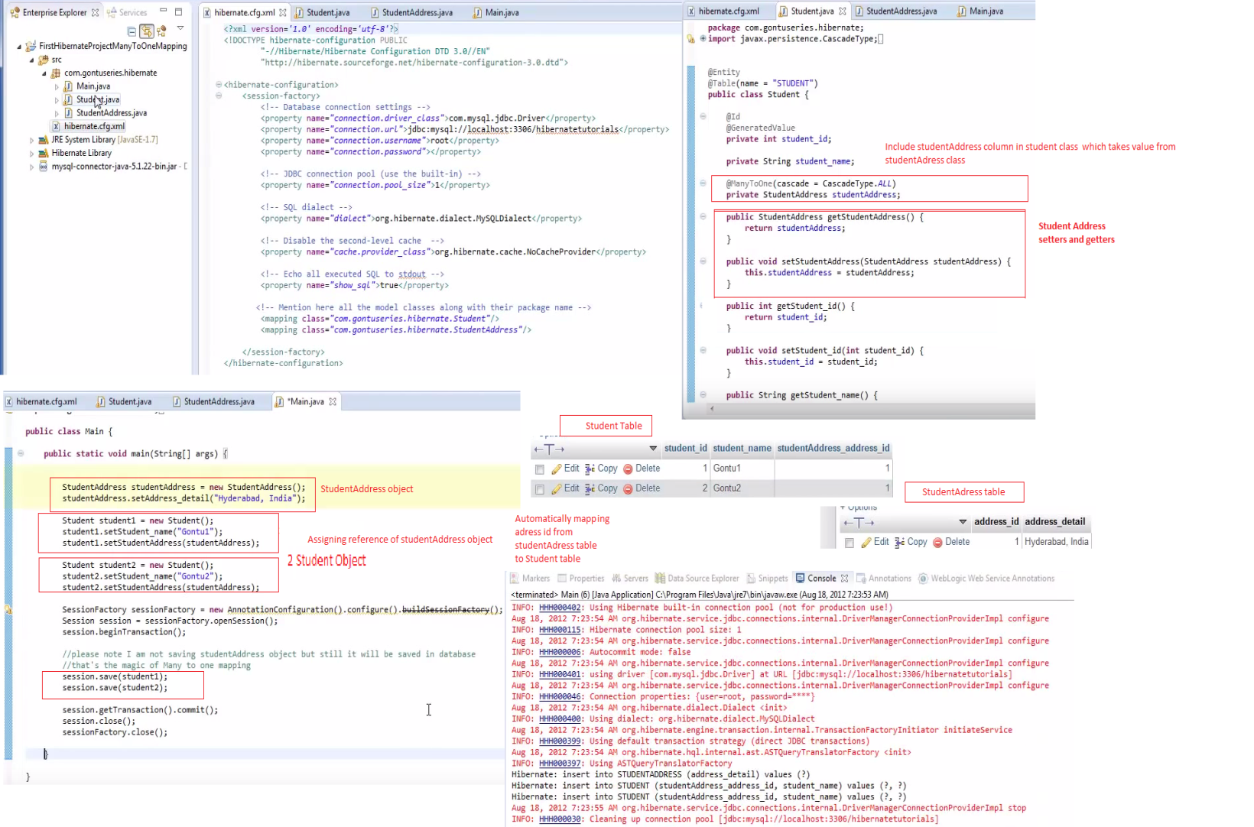

Hibernate Tutorial part 11 - ManyToOne / OneToMany Mapping (Bidirectional)

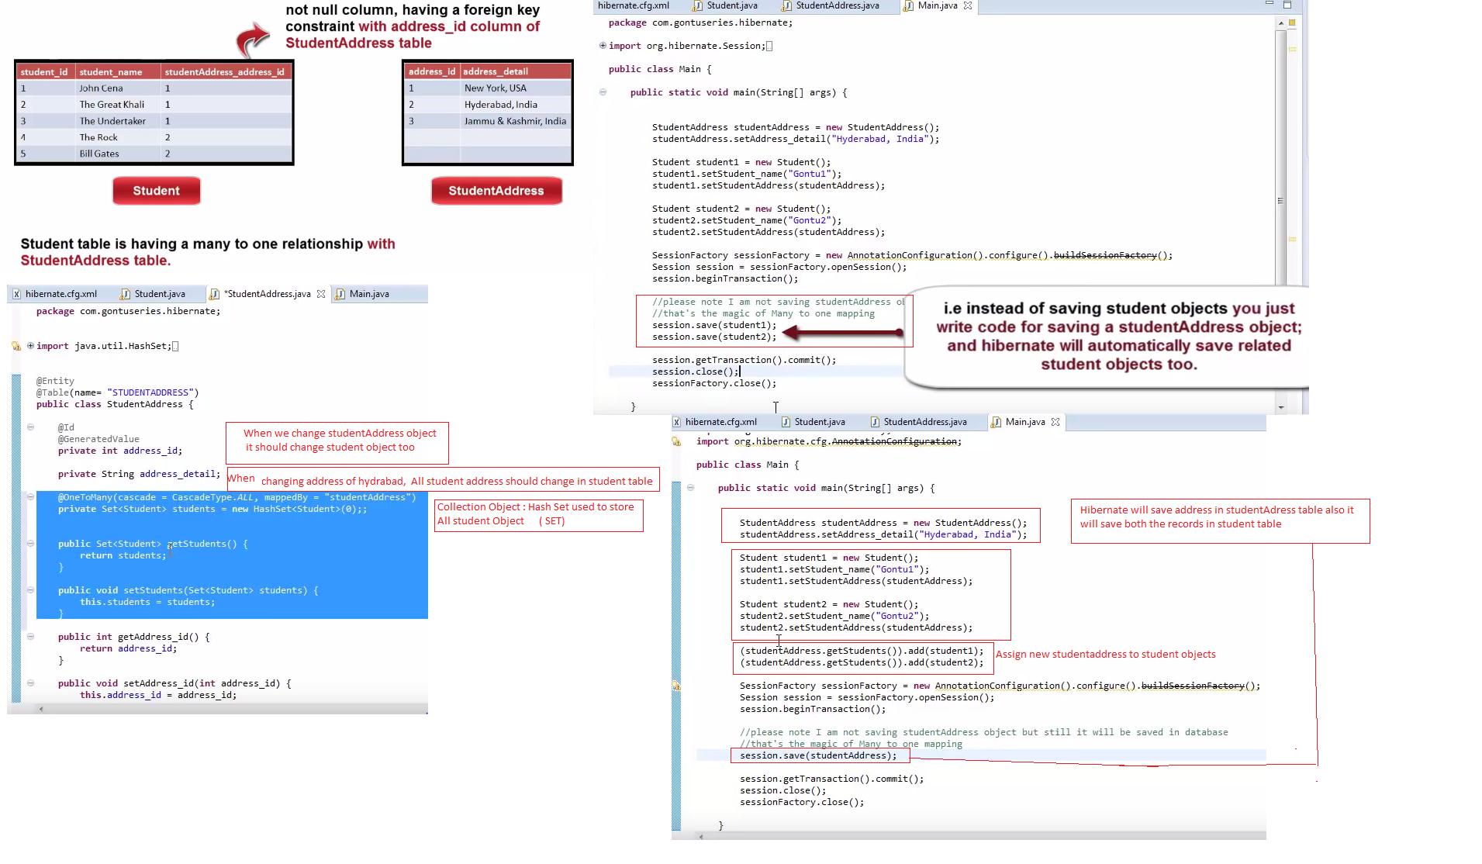

Hibernate Tutorial part 12 - MappedBy property concept in detail

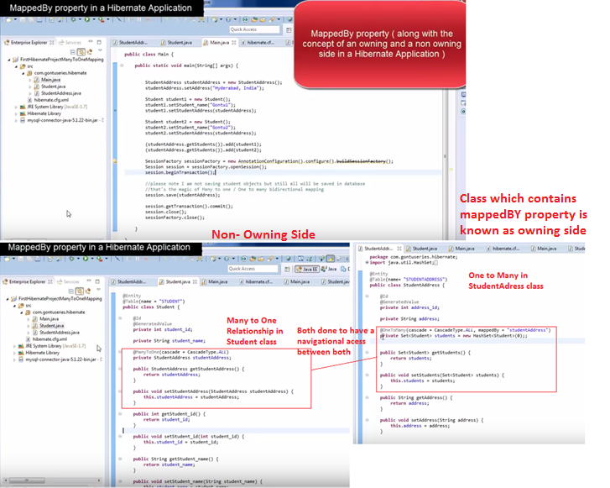

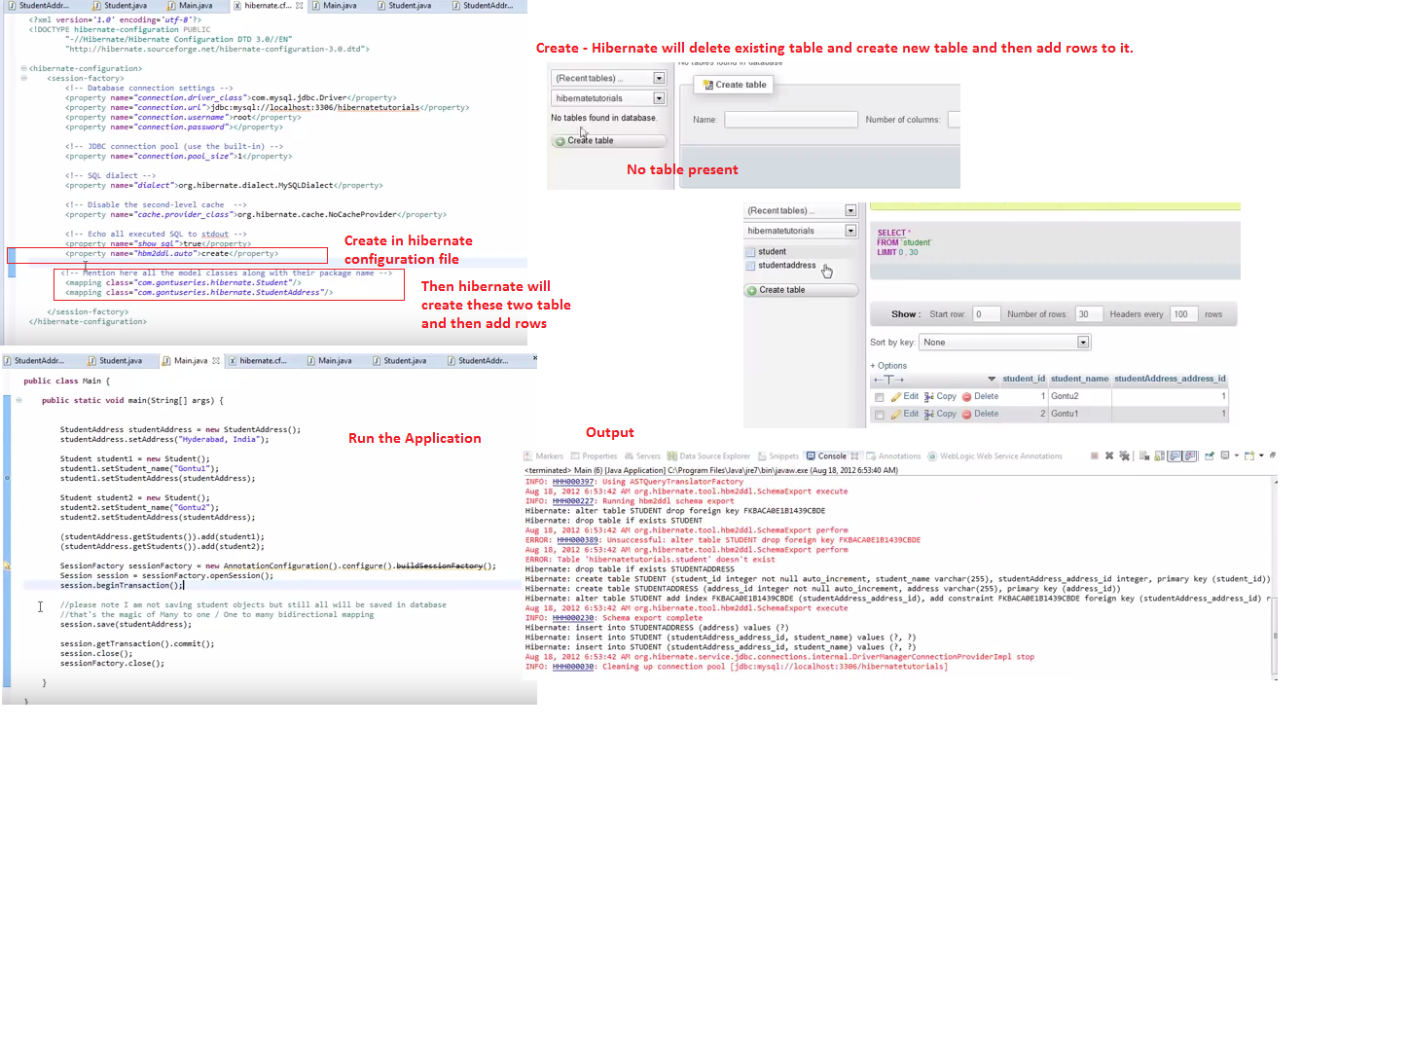

# Hibernate Tutorial part 13 - Many to Many mapping in detail

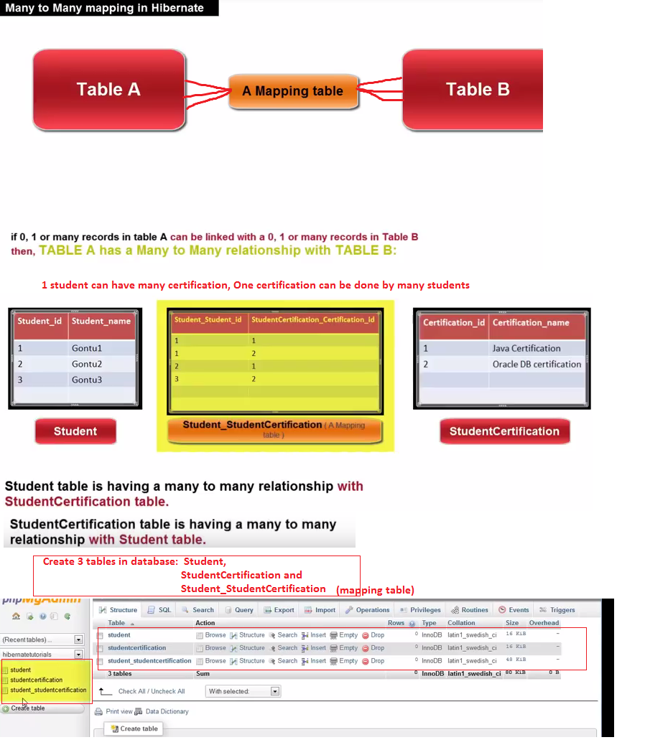

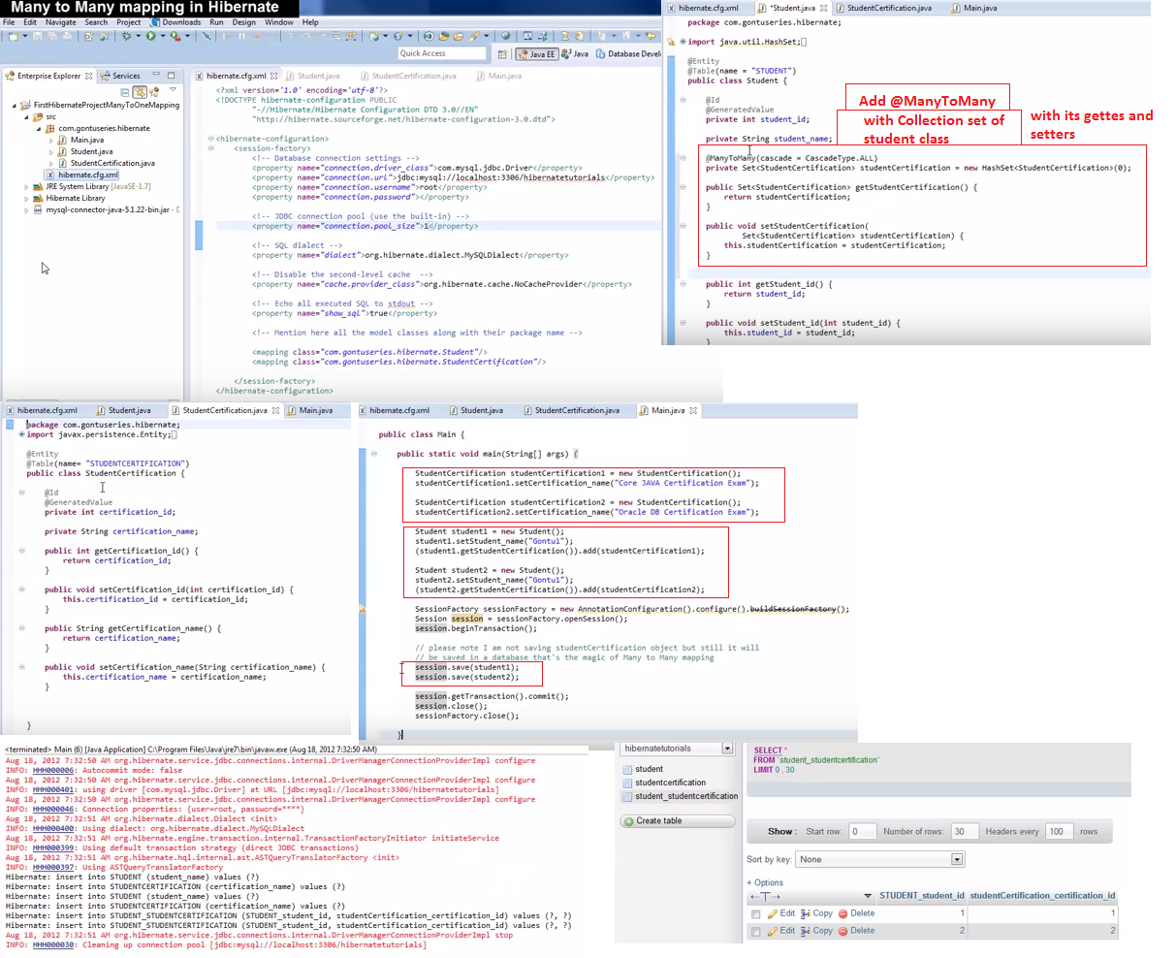

# Hibernate Tutorial part 14 - save, get, update, delete database operations using Hibernate (CRUD)

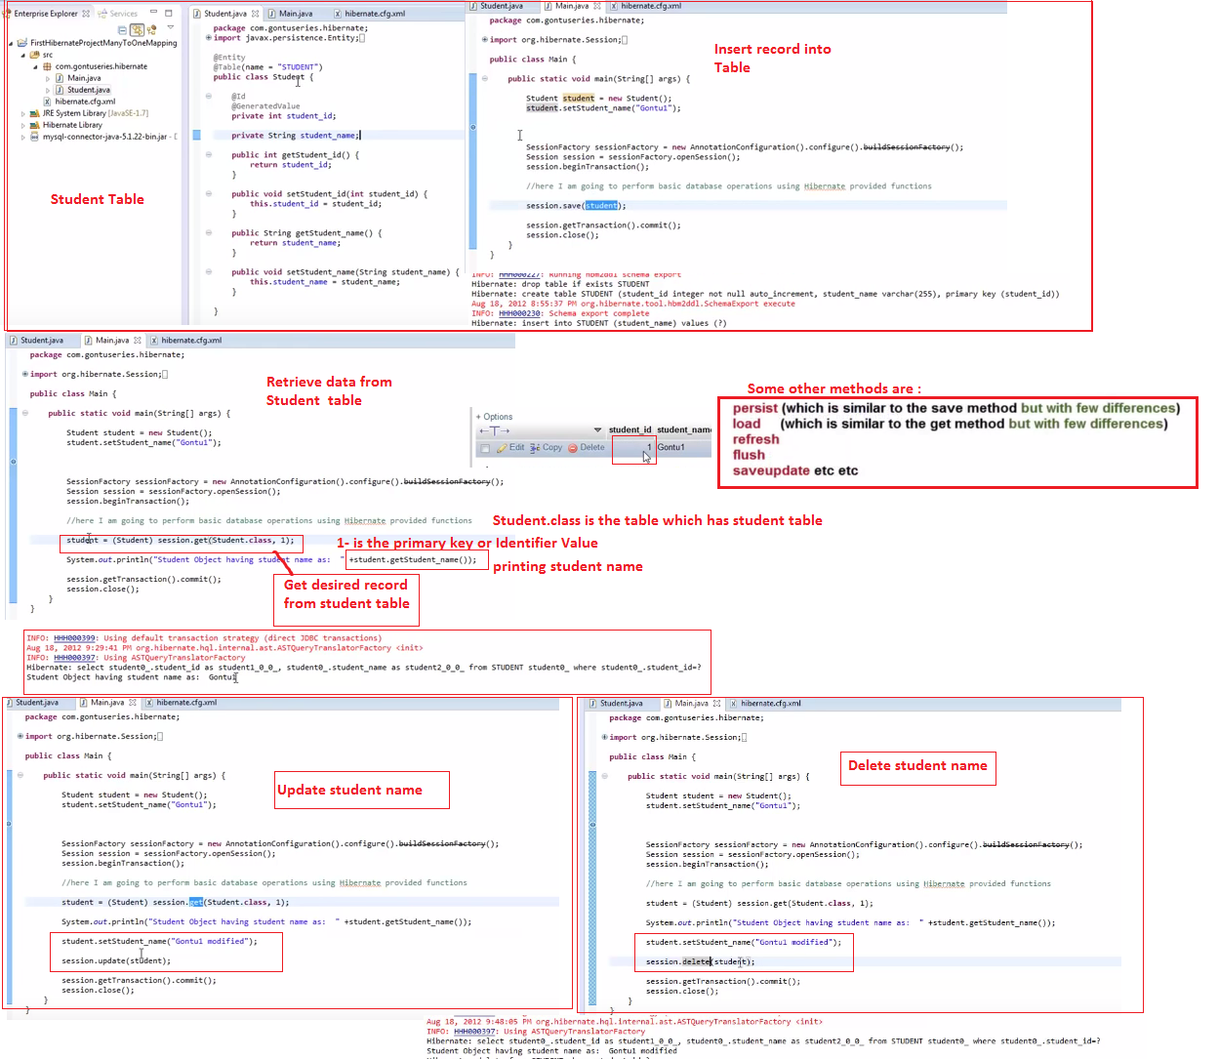

# Hibernate Tutorial part 15 - Hibernate Object States 01 (Transient, Persistent and Detached States)

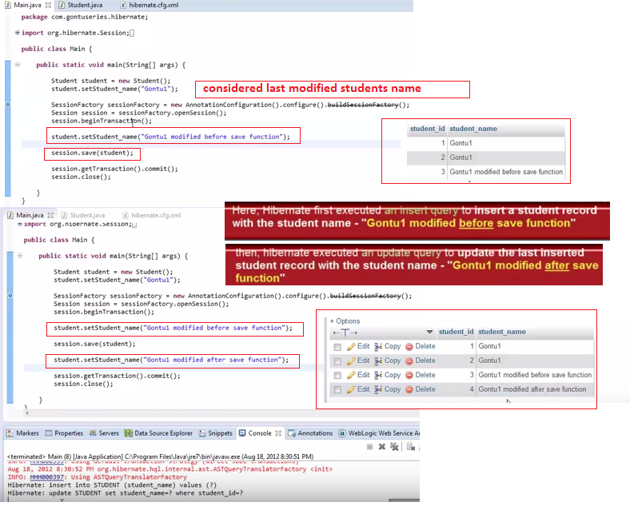

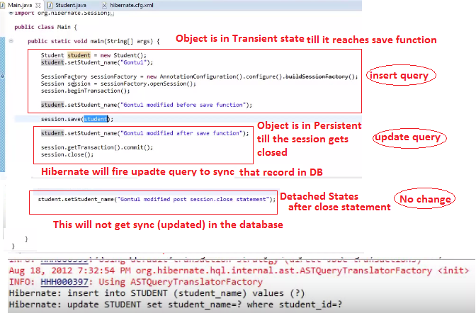

# Hibernate Tutorial part 16 - Hibernate Object States 02 (Transient, Persistent and Detached States) – Retrieve, Delete Record

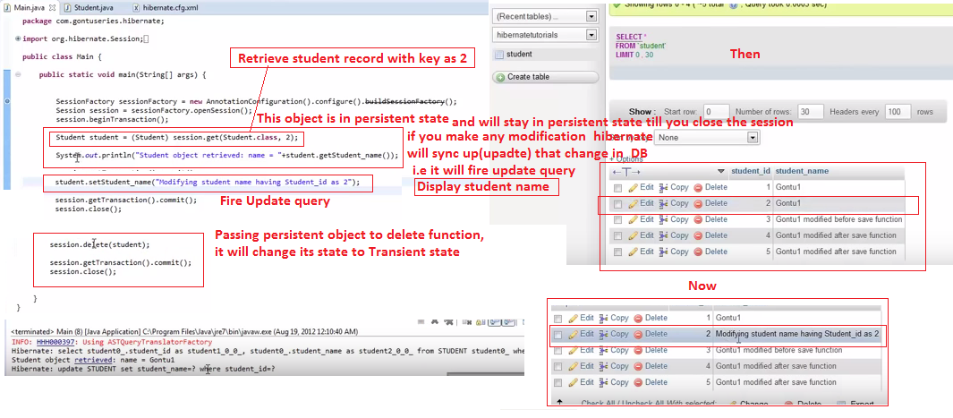

# Hibernate Tutorial part 17 - Hibernate Object States 03 (Transient, Persistent and Detached States)

